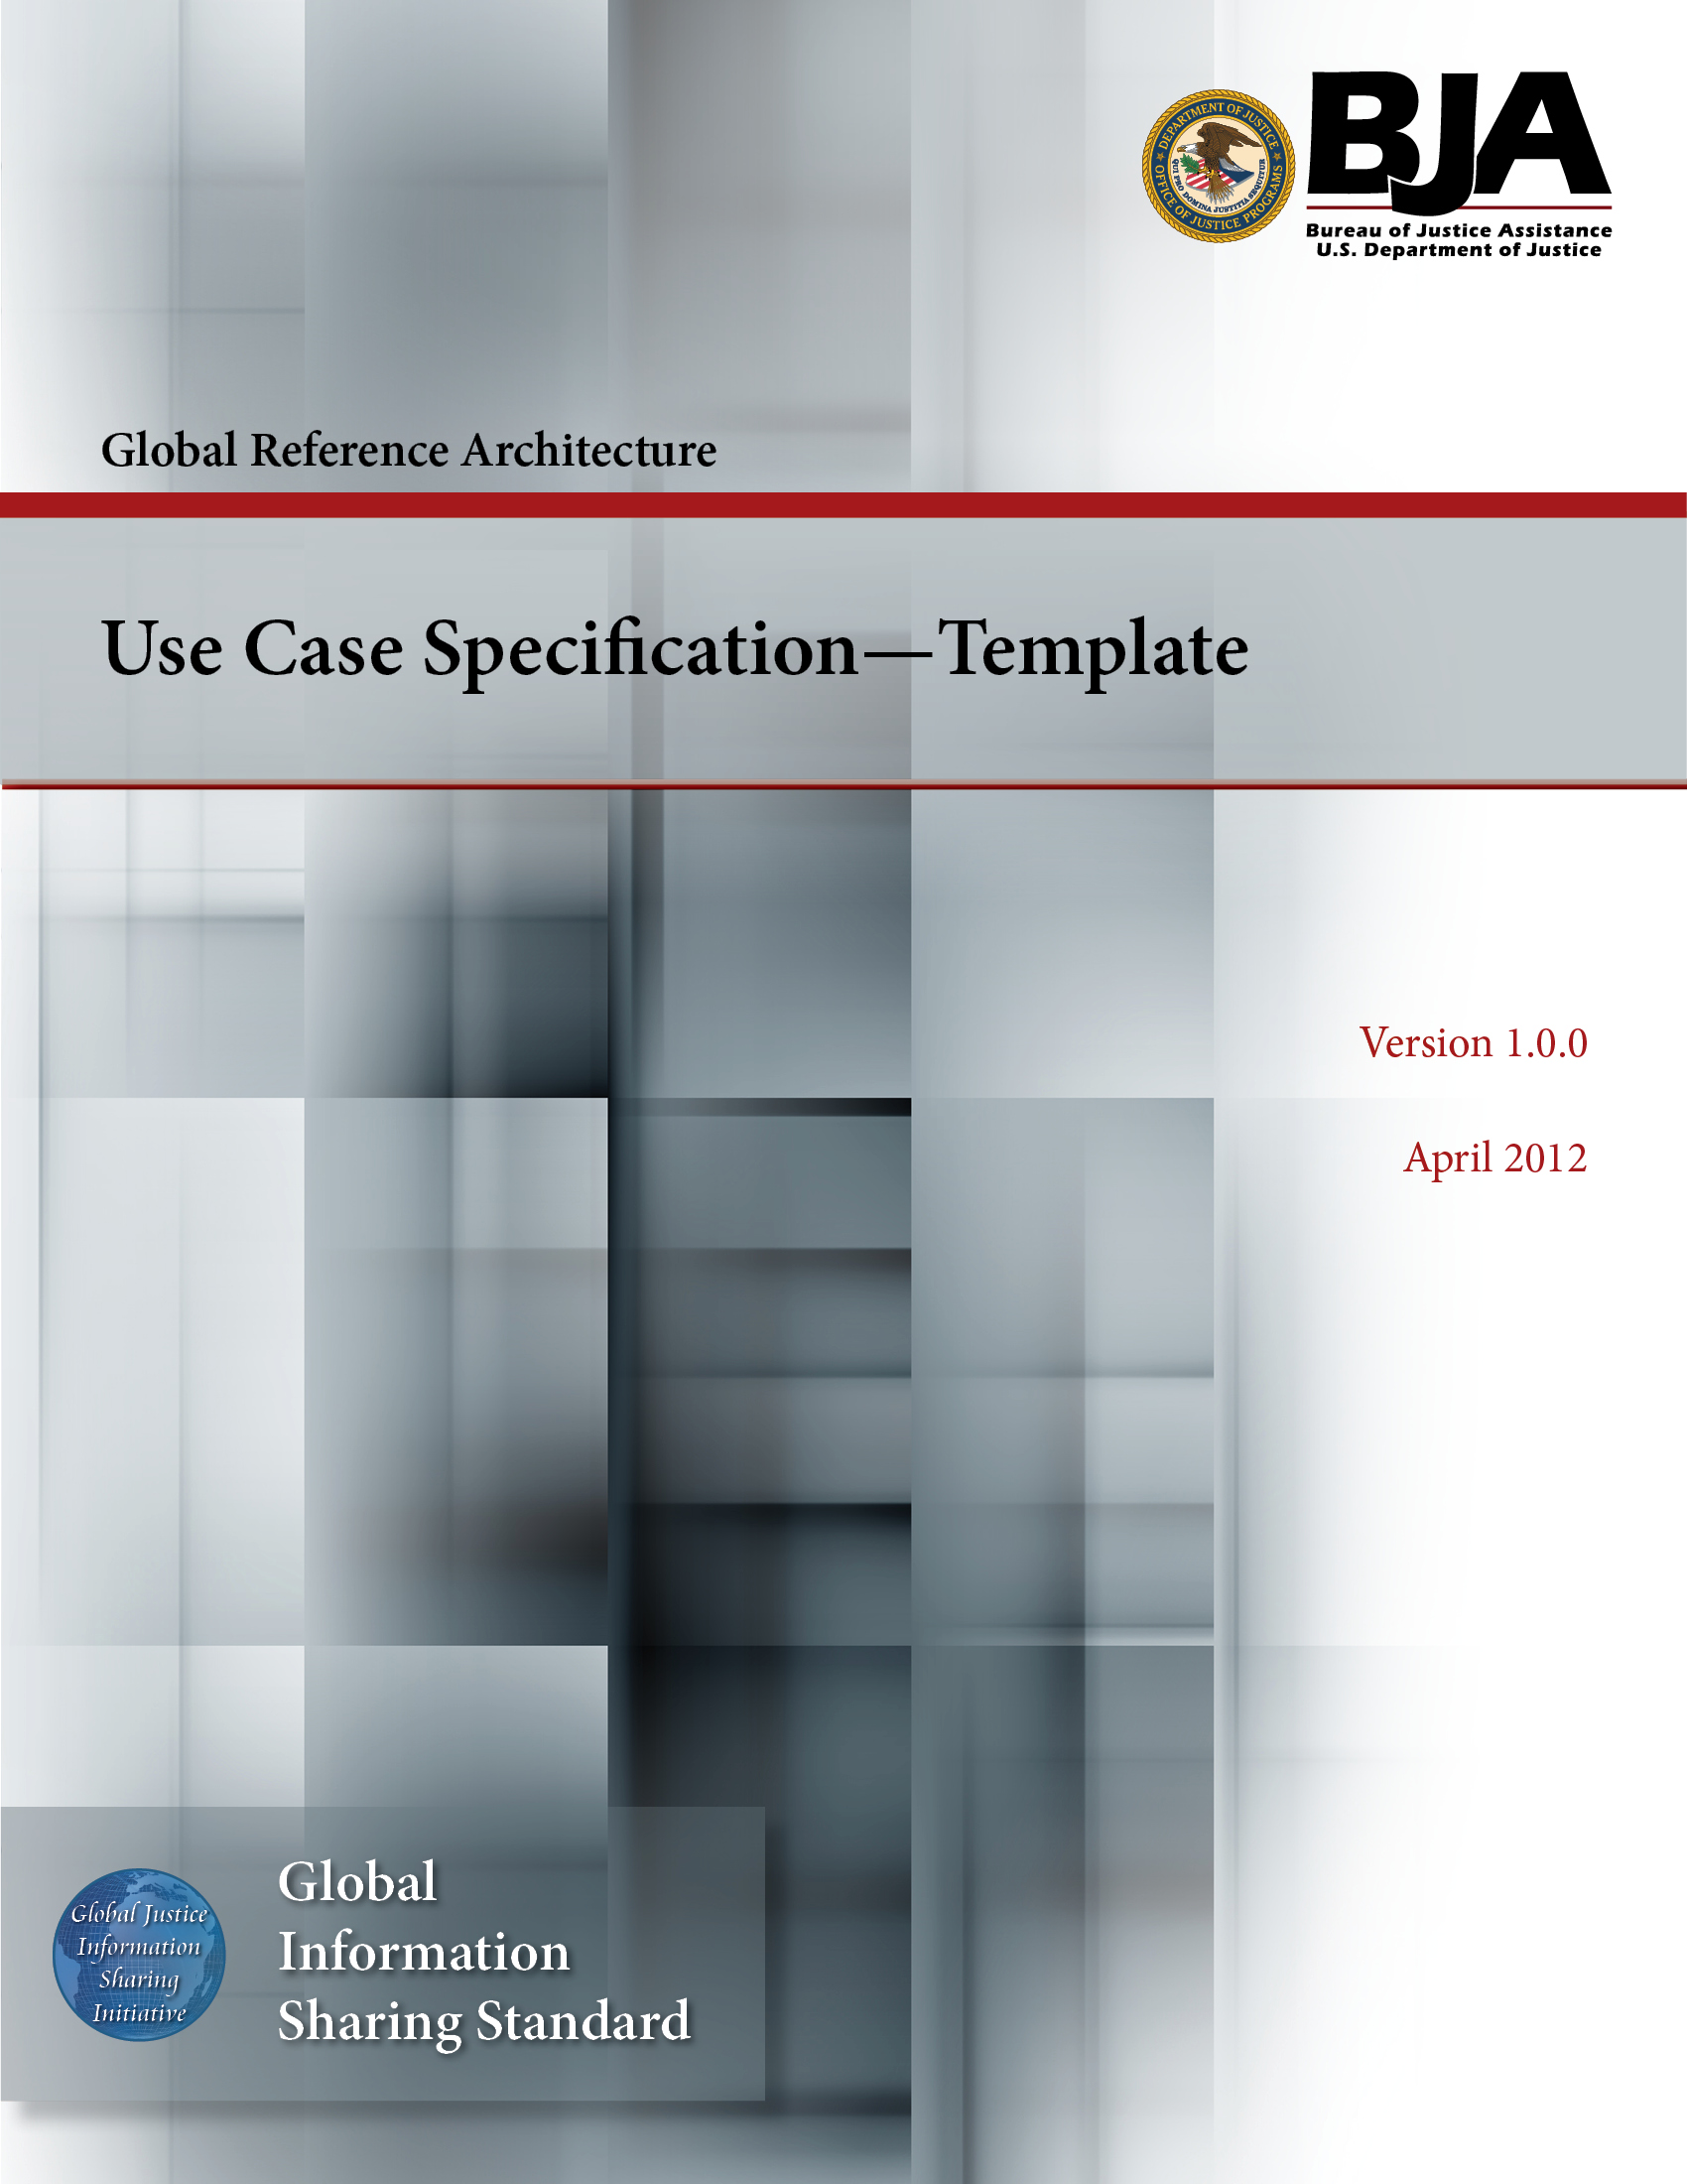


The Global Reference Architecture (GRA)

[Service Name] [Service Abbreviation] [Service Version]

Use Case Specification (Template)

Version 1.0.0

By [Name of Organization]

[Month Year]

Table of Contents

Document Conventions ii
Use Case Specification: <Use Case Name> 1
1. Actors 1
2. Brief Description 1
3. Flow of Events 1
3.1 Preconditions 1
3.2 Basic Flow 1
3.3 Alternative Flow(s) 2
3.3.1 <Area of Functionality> 2
3.3.2 <Another Area of Functionality> 2
3.4 Postconditions 3
4. Extension Points 3
4.1 <Name of Extension Point> 3
5. Special Requirements 3
5.1 <First Special Requirement> 3
6. Additional Information 3
Appendix A—References 4
Appendix B—Glossary 5
Appendix C—Document History 6

Document Conventions

[Note: The following template is provided for use with the Service Development Process. Text enclosed in square brackets and/or displayed in blue is included to provide guidance to the author and should be deleted before publishing the document.]

Use Case Specification: <Use Case Name>

Actors

[This section lists the actor(s) that interact with the use case. They are divided into two groups : Primary and Secondary. Primary actors are the ones who initiate the use case. Secondary actors, also called Supporting actors, are the ones used by the system. They are not part of the system and thus cannot be designed or altered. Secondary actors often represent external systems or commercial off-the-shelf components.]

Brief Description

[The description briefly conveys the role and purpose of the use case. A single paragraph will suffice for this description.]

Flow of Events

Preconditions

[A precondition of a use case is the state of the system that must be present prior to a use case being performed.]

Basic Flow

[This use case starts when the actor does something. An actor always initiates use cases. The use case describes what the actor does and what the system does in response. It is phrased in the form of a dialog between the actor and the system.

The use case describes what happens inside the system but not how or why. If information is exchanged, be specific about what is passed back and forth. For example, it is not very illuminating to say that the actor enters customer information if it is not defined. It is better to say the actor enters the customer’s name and address. A Glossary of Terms (or a more formal Domain Model) is essential to keep the complexity of the use case manageable⎯you may want to define things such as customer information there to keep the use case from drowning in details.

Simple alternatives may be presented within the text of the flow of events. If it only takes a few sentences to describe what happens when there is an alternative, do it directly within the flow. If the alternative flow is more complex, use a separate section to describe it. For example, an Alternative Flow subsection explains how to describe more complex alternatives.

Complex flow of events should be further structured into subflows. In doing this, the main goal should be improving the readability of the text. Subflows can be invoked many times from many places. Remember that the use case can perform subflows in optional sequences or in loops or even several at the same time.
A picture is sometimes worth a thousand words, though there is no substitute for clean, clear prose. If it improves clarity, feel free to paste flow charts, activity diagrams, or other figures into the use case. If a flow chart is useful to present a complex decision process, by all means use it! Similarly for state-dependent behavior, a state-transition diagram often clarifies the behavior of a system better than pages upon pages of text. Use the right presentation medium for your problem, but be wary of using terminology, notations, or figures that your audience may not understand. Remember that your purpose is to clarify, not obscure.]

Alternative Flow(s)

[More complex alternatives are described in a separate section, referred to in the Basic Flow subsection of Flow of Events section. Think of the Alternative Flow subsections as alternative behavior⎯each alternative flow represents alternative behavior, usually due to exceptions that occur in the main flow. They may be as long as necessary to describe the events associated with the alternative behavior.

Start each alternative flow with an initial line, clearly stating where the alternative flow can occur and the conditions under which it is performed.

End each alternative flow with a line that clearly states where the events of the main flow of events are resumed. This must be explicitly stated.

Using alternative flows improves the readability of the use case. Keep in mind that use cases are just textual descriptions, and their main purpose is to document the behavior of a system in a clear, concise, and understandable way.]

<Area of Functionality>

[Often there are multiple alternative flows related to a single area of functionality (for example, specialist withdrawal facilities, card handling, or receipt handling for the withdraw cash use case of an automated teller machine). It improves readability if these conceptually related sets of flows are grouped into their own clearly named subsections.]

< A1 First Alternative Flow >

[Describe the alternative flow, just like any other flow of events.]

<Another Area of Functionality>

[There may be, and most likely will be, a number of areas of functionality giving rise to sets of alternative flows. Keep each set of alternative flow separate to improve clarity.]

< AN Another Alternative Flow >

Postconditions

[A postcondition of a use case is a list of possible states in which the system can be immediately after a use case has finished.]

Extension Points

[This section is optional. It shows the extension points of the use case.]

<Name of Extension Point>

[Definition of the location of the extension point in the flow of events.]

Special Requirements

[A special requirement is typically a nonfunctional requirement that is specific to a use case but is not easily or naturally specified in the text of the use case’s event flow. Examples of special requirements include legal and regulatory requirements, application standards, and quality attributes of the system to be built including usability, reliability, performance, or supportability requirements. Additionally, other requirements⎯such as operating systems and environments, compatibility requirements, and design constraints⎯should be captured in this section.]

<First Special Requirement>

Additional Information

[Include, or provide references to, any additional information required to clarify the use case. This could include overview diagrams, examples, or anything else you fancy.]

Appendix A—References

[This section is used to list applicable references.]

[Reference name and description] | [Fully qualified link/path to the reference information]

Appendix B—Glossary

[This section is used to list glossary terms used in the document.]

[Glossary term or acronym] | [Glossary term or acronym description]

Appendix C—Document History

[This section is used to document the history of the service description document.]

Date | Version | Editor | Change
December 11, 2011 | 1.0.0 | James Dyche  Iveta Topalova | Final 1.0.0 revision
December 20, 2011 | 1.0.0 | David Gillespie | Initial edit of 1.0.0 revision
April 2012 | 1.0.0 | Global Standards Council (GSC) | Global Advisory Committee (GAC) approved



